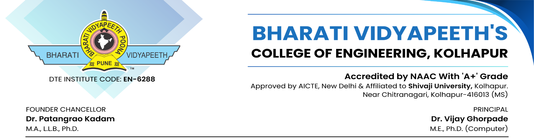

Date:-

MEMORANDUM OF UNDERSTANDING

In order to declare their joint intention to cooperate in some or all the fields of academics and industrial endeavor for their mutual benefit.
Party 1: Quadraloop
Party 2: Department of Computer Science & Engineering, Bharati Vidyapeeth’s college of Engineering, Kolhapur.
Agrees to explore opportunities for collaboration in the areas described here under:
- Sponsorship of final year project
- Sharing the technology for academic purpose only.
- Internship program for students as per requirements.
- Any other academic activity with mutual consent.

Quadraloop and Department of Computer Science & Engineering Bharati Vidyapeeth’s College of Engineering, Kolhapur agrees to share the information in strict confidence and will respect the intellectual property right of each other under the guide of Dr. P. A. Patel.

Dr. R. P. Mirajkar Dr. V. R. Ghorpade Mr. Pratik. G. Gaikwad
HOD -CSE Dept Principal Managing Director

